LESSON 1
SMARTPHONES

- READING
Read the reading passage carefully and then answer the following questions.
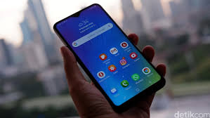
Smartphones are a class of mobile phones and of multi-purpose mobile computing devices. They are distinguished from feature phones by their stronger hardware capabilities and extensive mobile operating systems, which facilitate wider software, internet (including web browsing over mobile broadband), and multimedia functionality (including music, video, cameras, and gaming), alongside core phone functions such as voice calls and text messaging. Smartphones typically include various sensorsthat can be leveraged by their software, such as a magnetometer, proximity sensors, barometer, gyroscope and accelerometer, and support wireless communications protocols such as Bluetooth, Wi-Fi, and satellite navigation.
Early smartphones were marketed primarily towards the enterprise market, attempting to bridge the functionality of standalone personal digital assistant (PDA) devices with support for cellular telephony, but were limited by their bulky form, short battery life, and the immaturity of wireless data services; these issues were eventually resolved with advances in MOSFET (MOS transistor), lithium-ion battery and mobile network technologies. In the 2000s, NTT DoCoMo's i-mode platform, BlackBerry, Nokia's Symbian platform, and Windows Mobile began to gain market traction, with models often featuring QWERTY keyboards or resistive touchscreen input, and emphasizing access to push email and wireless internet. Since the unveiling of the iPhone in 2007, the majority of smartphones have featured thin, slate-like form factors, with large, capacitive screens with support for multi-touch gestures rather than physical keyboards, and offer the ability for users to download or purchase additional applications from a centralized store, and use cloud storageand synchronization, virtual assistants, as well as mobile payment services.

- COMPREHENSION
Answer the following questions briefly.
- What is the best title for the passage?
- According to the passage, what are the differences between smartphones and feature phones?
- What kinds of software were included in smartphones?
- When were Qwerty keyboards initially marketted?
- What are the changes to smartphones before and after the unveiling of iPhone in 2007 ?

- VOCABULARY
- Match the word/phrase in column A with its meaning or definition in column B.
No. | COLUMN A |  | COLUMN B
1. | devices |  | - The action of buying something
 | include |  | - An important topic or problem for debate or discussion.
3. | purchase |  | - gadget, utensil, tool, appliance
4. | issues |  | - The action of buying something.
5. | worldwide |  | - Throughout the world.
6. | issue |  | - comprise, encompass, cover, embrace, involve,

- Fill in the blanks with the correct words from the list above.
- At present, most schools ____bursaries to children talented in music, sport or the arts
- Resolving the abduction ____ is an urgent matter.
- She said offers had been received and they would like to see the property being ____ by locals
- These prices are per room per night and ____dinner and breakfast for two people caused by short circuits or power surges.
- Such articles include electronic ____, dust handling equipment and notebook computer enclosures.

- GRAMMAR FOCUS: Parts of speech: Noun, VerbAdjectives,
There are eight parts of speech in the English language; they arenoun, pronoun, verb, adjective, adverb, preposition, conjunction, and interjection. The part of speech indicates how the word functions in meaning as well as grammatically within the sentence. An individual word can function as more than one part of speech when used in different circumstances. Understanding parts of speech is essential for determining the correct definition of a word when using the dictionary. But, in this lesson you will only learn about Noun, Verb, adjective and Adverb.
- NOUN
A noun is a word that is used to give the name of a person, place, thing, or idea.
Example:Computer, accounting, system, operator, gadget, development and happiness
- VERB
A verb is a word that shows an action or state of being.
Example:Operate, terminate, reply, count, multiply, develop, delete, and reduce
- 4. ADJECTIVE
An adjective is a word that describes or modifies a noun or a pronoun.
Example: Modern, multiple, optimal, quick, eligible, responsible, and beneficial.
- ADVERB
An adverb is a word that modifies a verb, an adjective or another adverb.
Example: carefully, extremely, very, really, systematically, and automatically.

- Complete this list with nouns, verbs, adjectives, and adverb. Number is given as the example.
 | NOUN | VERB | ADJECTIVE | ADVERB
1 | building | build | - | -
2 | honesty | - | honest | honestly
3 |  |  | good
4 |  |  |  | carelessly
5 |  |  | important
6 | responsibility
7 |  |  | additional
8 |  |  |  | closely
9 |  | support
10 |  |  | easy
11 | assignment
12 |  |  | special

- After filling in the list, write 10 sentences using 10 different words (parts of speech) from the list above. Look at the example.
*You can build database applications without writing any code.
*There were several buildings damaged by the hurricane.

- Choose the letter of the word or group of words that best completes the sentence.
- The proposal has _____ a lot of interest.  - general  - generated  - generation  - generally | - During the past half-century, biological sciences have been changing the world, scientifically, ____ and sociallysimultaneous  - technology  - technological  - technologically  - technologist
- There were several ____ attacks by the rebels.generated  - simultaneous  - simultan  - simultaneously  - simultaneity | - She went to Hollywood in search of ____ and fortune.  - famous  - famously  - fame  - familiar
- During the past half-century, biological sciences have been changing the world, scientifically, ____ and sociallysimultaneous  - technology  - technological  - technologically  - technologist | - A new type of painkilling drug has recently been ______.  - developing  - developed  - development  - developmental

- In these questions, each sentence has four underlined words or phrases. The four underlined parts of the sentence are marked (A), (B), (C) and (D). Identify the one underlined word or phrase that must be changed in order for the sentence to be correct. Then, on your answer sheet, find the number of the question and fill in the space that corresponds to the letter of the answer you have chosen.
- He knew I was energeticallyand dynamic and would get things done.
- (B) (C) (D)

- Jeremy and Ienclose the two plansfor comparison.
- (B) (C) (D)

- The government provided an additional £25 million to expansionthe service.
- (B) (C) (D)

- The important of this question has been acknowledged on all sides in the
- (B) (C)
present case.
(D)

- WRITING: Sentence Construction
Writing is constructed by putting sentences in sequence, one after another and, if a single sentence is read aloud, it should be understandable.
Meaning should flow from one sentence to the next, carrying the argument or point of view forward in a clear and concise manner. If you do not use correct grammar and punctuation, or your sentences are too long and complex, what you are trying to say will become unclear and the reader will be unable to follow the text because the flow of meaning is interrupted.
A sentence is a collection of words that convey sense or meaning and is formed according to the logic of grammar. Clear, short sentences are preferable, and more effective, than long, complex ones.
Study the examples and then practice writing sentences using the words below.
Example:
Great =>Teddy showed great potential as an actor.
Protect =>He tried to protect his friend from the attack.
Strange =>Children sometimes have strange ideas.

- Look at the words and phrases below. Rearrange them to form meaningful sentences to make a reading passage. Write the correct sentences in the space provided.
- one of / friends / a / best / good / our / is / book
..............................................................................................................................................
- the same / and it / it is / change / will never / today that / it always was
..............................................................................................................................................
- most patient / companions / cheerful of / it / and / is the
..............................................................................................................................................
- turn its / in times / it does / of adversity / back upon / or distress / not / us
..............................................................................................................................................
- Big business / is a / It / centre / and / educational
..............................................................................................................................................

- Now please practice constructing sentences using these words.
Advantage =>...........................................................................................................
Responsible =>...........................................................................................................
Arrange =>...........................................................................................................
Determine =>...........................................................................................................
Selection =>...........................................................................................................
Both =>...........................................................................................................
Pretend => ...........................................................................................................
Slowly => ...........................................................................................................
Strength => ...........................................................................................................
Achievement =>...........................................................................................................

LESSON 2
UNMANNED AERIAL VEHICLE

- READING
Read the reading passage carefully and then answer the following questions.
An unmanned aerial vehicle (UAV) (or uncrewed aerial vehicle, commonly known as a drone) is an aircraft without a human pilot on board and a type of unmanned vehicle. UAVs are a component of an unmanned aircraft system (UAS); which include a UAV, a ground-based controller, and a system of communications between the two. The flight of UAVs may operate with various degrees of autonomy: either under remote control by a human operator or autonomously by onboard computers.
Compared to crewed aircraft, UAVs were originally used for missions too "dull, dirty or dangerous" for humans. While they originated mostly in military applications, their use is rapidly expanding to commercial, scientific, recreational, agricultural, and other applications, such as policing and surveillance, product deliveries, aerial photography, smuggling, and drone racing. Civilian UAVs now vastly outnumber military UAVs, with estimates of over a million sold by 2015. Multiple terms are used for unmanned aerial vehicles, which generally refer to the same concept.
The term drone, more widely used by the public, was coined in reference to the early remotely-flown target aircraft used for practice firing of a battleship's guns, and the term was first used with the 1920s Fairey Queen and 1930's de Havilland Queen Bee target aircraft. These two were followed in service by the similarly-named Airspeed Queen Wasp and Miles Queen Martinet, before ultimate replacement by the GAF Jindivik.

[
- COMPREHENSION
- Answer the following questions briefly.
- What is the best title for the passage?
- How can UAV be operated to fly?
- What does paragraph 2 mainly discuss ?
- What was the word ‘drone’ firstly used?
- How do you describe a drone?

- Write T if the statement is true, F if it is false, or NC if it not clear according to the passage.
- ___UAV is an aircraft operated by a human operator.
- ___ Drone is a software included in UAV.
- ___ UAV was firstly operated to fly in US
- ___There are many names used for UAV.
- ___The term drone is better known than UAV.

- VOCABULARY
- Match the word/phrase in column A with its meaning or definition in column B.
No. | COLUMN A |  | COLUMN B
1. | aircraft |  | - Be more numerous than
2. | rapidly |  | - very fast, very quickly
3. | commercial |  | - Close observation, especially of a suspected spy or criminal.
4. | surveillance |  | - Concerned with or engaged in commerce
5. | outnumber |  | - An aeroplane, helicopter, or other machine capable of flight.

- Fill in the blanks with the correct words from the list above.
- In the heat, the grass grows ____ and the flowers wilt fast, so there was much to be done.
- It is understood police had the suspects under ____for weeks before the robbery.
- At this debate, the press ____the attendants 4 to 1.
- Launched with this jumbo team aboard for a test flight, the ____failed to gain height
- A ____agreement is between the parties concerned and should have nothing to do with what anyone else wants.

- GRAMMAR FOCUS: Subject-Verb Agreement

Subjects and verbs must agree with one another in number (singular or plural). Thus, if a subject is singular, its verb must also be singular; if a subject is plural, its verb must also be plural.

Here are some subject-verb agreement rules.
1. A phrase or clause between subject and verb does not change the number of the subject.
Examples:
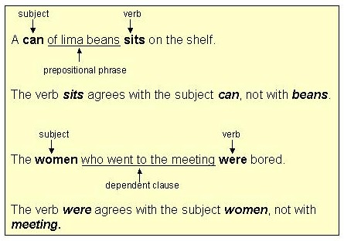

2. Indefinite pronouns as subjects
Singular indefinite pronoun subjects take singular verbs.

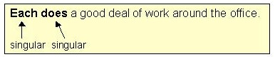

- Plural indefinite pronoun subjects take plural verbs.
PLURAL: several, few, both, many
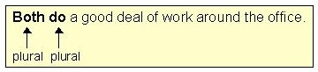
Some indefinite pronouns may be either singular or plural: with uncountable, use singular; with countable, use plural.
EITHER SINGULAR OR PLURAL: some, any, none, all, most

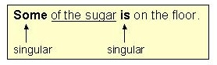
- Sugar is uncountable; therefore, the sentence has a singular verb.
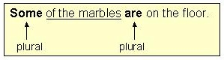
- Marbles are countable; therefore, the sentence has a plural verb.
3. Compound subjects joined by and are always plural.
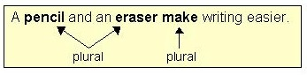

4. With compound subjects joined by or/nor, the verb agrees with the subject
nearer to it.
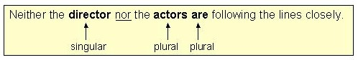
In the above example, the plural verb are agrees with the nearer subject actors.
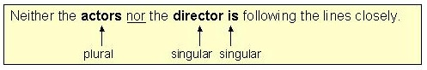
In this example, the singular verb is agrees with the nearer subject director.

5. Inverted Subjects must agree with the verb.
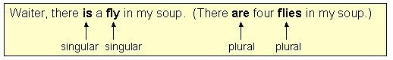
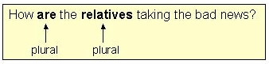
6. Collective Nouns (group, jury, crowd, team, etc.) may be singular or plural,
depending on meaning.
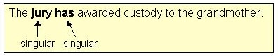
In this example, the jury is acting as one unit; therefore, the verb is singular.
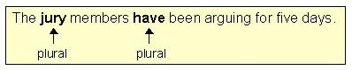
In this example, the jury members are acting as twelve individuals; therefore, the verb is plural.

Titles of single entities (books, organizations, countries, etc.) are always singular.
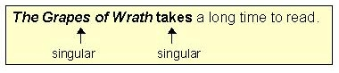
8. Plural form subjects
- Plural form subjects with a singular meaning take a singular verb.(e.g. news, measles, mumps, physics, etc.)
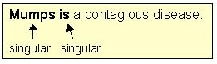
- Plural form subjects with singular or plural meaning take a singular or plural verb, depending on meaning.(e.g. politics, economics, etc.)
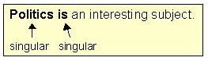
In this example, politics is a single topic; therefore, the sentence has a singular verb.
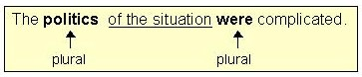
In this example, politics refers to the many aspects of the situation; therefore, the sentence has a plural verb.
- Plural form subjects with a plural meaning take a plural verb. (e.g. scissors, trousers)
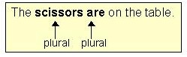
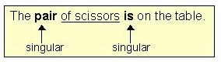
Note: In this example, the subject of the sentence is pair; therefore, the verb must agree with it. (Because scissors is the object of the preposition, scissors doesnot affect the number of the verb.)
- With subject and subjective complement of different number, the verb always
agrees with the subject.
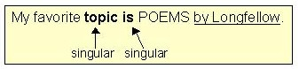
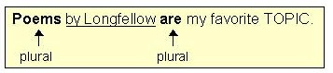

- Choose the letter of the word or group of words that best completes the sentence.
- Plenty of mangoes and bananas _____ available in this season.  - is  - are  - have  - be | - Cats and dogs _____ not get along.  - is  - are  - do  - does
- The students accompanied by their teacher _____ gone on a picnic.  - are  - do  - has  - have | - A large sum of money ____stolen.  - is  - are  - being  - has
- ____ houses have collapsed in the storm.
- Little
- Much
- A lot
- A lot of

- In these questions, each sentence has four underlined words or phrases. The four underlined parts of the sentence are marked (A), (B), (C) and (D). Identify the one underlined word or phrase that must be changed in order for the sentence to be correct. Then, on your answer sheet, find the number of the question and fill in the space that corresponds to the letter of the answer you have chosen.
- There are many factor affecting teacher retention.
- (B) (C) (D)

- The focus of the interviewswere nine purposively selected participants.
- (B) (C) (D)

- An assumptionis something that is generally accepted as true and bean important
- (B) (C)
consideration when conducting a doctoral study.
(D)
- It is believed that these purchases will bringlucky and prosperity to the buyers.
(A) (B) (C) (D)

- Eachof the participants were willing to be recorded.
- (B) (C) (D)

- WRITING: Sentence Construction
In English there are many verb patterns that can be used to describe ideas that you want to write into sentences. In this lesson you will learn about these verb patterns:
Patten 1 : S + V + INFINITIVE

- They decided to stay at home.
- We need to buy a bigger car.
- Mr. Felix wants to talk to the guests.
Pattern 2 : S + V + -ING
- Verbs of likes and dislikes: like, dislike, hate, detest, love, prefer, enjoy...
- Ken likes reading comics.
- I enjoy listening to music.
- She hates walking in the rain.
- I love singing in the shower
In modern English these verbs can also be used with infinitive with no real Other verbs: finish, stop, quit, mind, keep, practice, go on, consider, suggest ...
- Would you mind opening the window?
- Jack has stopped smoking.
- She suggested going to Cancun for the summer

- Look at the words and phrases below. Rearrange them to form meaningful sentences to make a reading passage. Write the correct sentences in the space provided.
- something/tell /to /Tom /wanted/you
- a couple extra /days /to /Boston /in /I /stay /decided
- children /go /Tom /allow /his /to /out /after /dark /doesn't
- to /something /eat /We /get /to /need
- tried /him /to /with /She /make friends

- Now please practice constructing sentences using these words.
- (decide) ............................................................................................................
- (try)...................................................................................................................
- (allow) .............................................................................................................
- (ask) ................................................................................................................
- (stop) ...............................................................................................................
- (mind) ..............................................................................................................
- (enjoy) .............................................................................................................
- (keep) ..............................................................................................................

LESSON 3

DIGITALMARKETING

- READING
Read the reading passage carefully and then answer the following question.

Digital marketing is the marketing of products or services using digital technologies, mainly on the Internet, but also including mobile phones, display advertising, and any other digital medium. Digital marketing channels are systems based on the internet that can create, accelerate, and transmit product value from producer to the terminal consumer by digital networks.
Digital marketing's development since the 1990s and 2000s has changed the way brands and businesses use technology for marketing. As digital platforms are increasingly incorporated into marketing plans and everyday life, and as people use digital devices instead of visiting physical shops, digital marketing campaigns are becoming more prevalent and efficient.
Digital marketing methods such as search engine optimization (SEO), search engine marketing (SEM), content marketing, influencer marketing, content automation, campaign marketing, data-driven marketing, e-commerce marketing, social media marketing, social media optimization, e-mail direct marketing, Display advertising, e–books, and optical disks and games are becoming more common in our advancing technology. In fact, digital marketing now extends to non-Internet channels that provide digital media, such as mobile phones (SMS and MMS), callback, and on-hold mobile ring tones. In essence, this extension to non-Internet channels helps to differentiate digital marketing from online marketing, another catch-all term for the marketing methods mentioned above, which strictly occur online.

- COMPREHENSION
Answer these questions briefly.
    - What is the best title of the article?
    - What do digital marketing channels function?
    - What do you know about digital marketing methods?
    - How do you interpret this sentence “people use digital devices instead of visiting physical shops”? (line 8)
    - How digital marketing and online marketing differ?

- VOCABULARY
- Match the word/phrase in column A with its meaning or definition in column B.
No. | COLUMN A |  | COLUMN B
1. | digital |  | - line, label, marque
2. | value |  | - widespread, prevailing, frequent,
3. | consumer |  | - typically represented by values of a physical quantity such as voltage or magnetic polarization
4. | accelerate |  | - by itself with little or no direct human control.
5. | brands |  | - worth, usefulness, use,
6. | platforms |  | - make available for use; supply.
7. | prevalent |  | - purchaser, buyer, customer,
8. | provide |  | - expand, enlarge, increase,
9. | extends |  | - speed up, hurry up, get faster,
10. | differentiate |  | - make (someone or something) appear different or distinct

- (ii) Fill in the blanks with the correct words from the list above.aaa Make necessary
changes when needed.
- We plan to support more hardware ____ and operating systems.
- The receiving modem translates the analog signals back to ____ form.
- The group is active in repairing schools and ____ `educational supplies.
- Professional psychology has always emphasized the ____ `of respecting privacy.
- Pilots have spoken of the dangerous winds ____ in the area where the friends were last heard from.
- The job of businessmen is to stay on guard as far as ____ s' demands are concerned.’
- It is for the same reason the council has asked for the boundary to be ____ in the Chalumna area.
- Biotechnology will continue to advance and its rate of advance will ____.
- Three characteristics or properties ____ laser light from ordinary light.
- There are ____, products and categories and each has a slightly different meaning.

- GRAMMAR FOCUS: Linking Verbs

Linking verbs are verbs that serve as a connection between a subject and further information about that subject. They do not show any action; rather, they “link” the subject with the rest of the sentence. The verb to be is the most common linking verb, but there are many others, including all the sense verbs.

Verbs that are immediately followed by an adjective are usually called "linking verbs". The adjective following a linking verb describes the subject of a sentence. Let's see the following examples :
- She looks beautiful.
- The soup tastes good.

The underlined words are linking verbs.
The following verbs are the linking verbs.
- be ( am, is, are, was, were, will be, was being, has been.)
- appear
- become
- feel
- look
- seem
- sound
- taste
Here are some examples of linking verbs (shaded) re-identifying the subject:
- Alan is a beast.
- His father was the headmaster.
- This project is a disaster.
Here are some examples of linking verbs (shaded) modifying the subject:
- Alan seems drunk.
- The soup smells delicious.
- His voice sounds flat.

  - Choose the letter of the word or group of words that best completes the sentence.
- The cake does not ___ sweet.  - appear  - taste  - look  - sound | - The princess ... so beautiful.  - appear  - taste  - look  - sound
- The children ... happy.  - is  - are  - look  - sound | - The perfume ... jasmine.  - tastes  - sounds  - smells  - looks
- Those leaves ... brown.
A. taste
B. turn
C. smell
D. looks

  - In these questions, each sentence has four underlined words or phrases. The four underlined parts of the sentence are marked (A), (B), (C) and (D). Identify the one underlined word or phrase that must be changed in order for the sentence to be correct. Then, on your answer sheet, find the number of the question and fill in the space that corresponds to the letter of the answer you have chosen.
    - A lot of people feels unhappy with the government.
(A) (B) (C) (D)

    - Mr. Oemar looks very carefully in counting the figures .
(A) (B) (C) (D)

    - Her face turningred when those boys entice her.
(A) (B) (C) (D)

    - Ben’snew car is look very luxurious.
(A) (B) (C) (D)

    - My little son grow smarter each day.
(A) (B) (C) (D)

- WRITING: Sentence Construction

- Look at the words and phrases below. Rearrange them to form meaningful sentences to make a reading passage. Write the correct sentences in the space provided.
- might /more /She /with /look /a little make-up/ attractive
..................................................................................................................................
- Watermelon tastes delicious on a hot day
..................................................................................................................................
- his /father /He /felt / lost / because /he /sad
..................................................................................................................................
- seem /They/do /too /not /busy.
..................................................................................................................................
- 1963/Kenya /independent /became /in
..................................................................................................................................

- Now please practice constructing sentences using these words.
- (look) ................................................................................................................
- (feel)...................................................................................................................
- (sound) ..............................................................................................................
- (taste) ................................................................................................................
- (seem) ...............................................................................................................
- (appear) ............................................................................................................
- (become) ..........................................................................................................
- (turn) ...............................................................................................................

Bottom of Form

LESSON 4

ARTIFICIAL INTELLIGENCE

- READING
Read the article below carefully and then answer the following question.
In computer science, artificial intelligence (AI), sometimes called machine intelligence, is intelligence demonstrated by machines, in contrast to the natural intelligence displayed by humans. Colloquially, the term "artificial intelligence" is often used to describe machines (or computers) that mimic "cognitive" functions that humans associate with the human mind, such as "learning" and "problem solving".
Artificial intelligence can be classified into three different types of systems: analytical, human-inspired, and humanized artificial intelligence. Analytical AI has only characteristics consistent with cognitive intelligence; generating a cognitive representation of the world and using learning based on past experience to inform future decisions. Human-inspired AI has elements from cognitive and emotional intelligence; understanding human emotions, in addition to cognitive elements, and considering them in their decision making. Humanized AI shows characteristics of all types of competencies (i.e., cognitive, emotional, and social intelligence), is able to be self-conscious and is self-aware in interactions.
The traditional problems (or goals) of AI research include reasoning, knowledge representation, planning, learning, natural language processing, perception and the ability to move and manipulate objects. General intelligence is among the field's long-term goals. Approaches include statistical methods, computational intelligence, and traditional symbolic AI. Many tools are used in AI, including versions of search and mathematical optimization, artificial neural networks, and methods based on statistics, probability and economics. The AI field draws upon computer science, information engineering, mathematics, psychology, linguistics, philosophy, and many other fields.

- COMPREHENSION
Answer these questions briefly.
- Why is artificial intelligence named machine intelligence?
- How does artificial intelligence function?
- What are the three types of system in AI?
- What do traditional goals of AI research?
- How do you describe ‘artificial intelligence’?

- VOCABULARY
- Match the word/phrase in column A with its meaning or definition in column B.
No. | COLUMN A |  | COLUMN B
1. | artificial |  | - link, connect,
2. | associate |  | - relating to cognition.
3. | cognitive |  | - The study of the fundamental nature of knowledge, reality, and existence, especially when considered as an academic discipline
4. | competence |  | - made or produced by human beings rather than occurring naturally, especially as a copy of something natural.
5. | philosophy |  | - capability, ability

- (ii) Fill in the blanks with the correct words from the list above.aaa Make necessary
  - changes when needed.
- Research in ____ psychology has shown that we remember iconic images better than text.
- Some employees are enthusiastic about their supervisor's ____and skills.
- This system uses ambient light rather than an artificial light source.
- Theology ‘is an academic discipline like ____, English literature or the classics,’ he said.
- People have always ____the mind with the technological fad of the moment.

- GRAMMAR FOCUS: Auxiliary Verbs

Auxiliary (or Helping) verbs are used together with a main verb to show the verb’s tense or to form a negative or question. The most common auxiliary verbs are have, be, and do.
Example:
- Does Sam write all his own reports?
- The secretaries haven’t written all the letters yet.
- Terry is writing an e-mail to a client at the moment.
In addition to the three main auxiliary verbs, have, do, and be, there are additional auxiliary verbs. These are called modal auxiliary verbs, and they never change form. They are : can, could, may, might, must, ought to, shall, will, would.

Here are some examples of auxiliary verbs and verb phrases.
- Jessica is taking John to the airport.
- If he doesn’t arrive on time, he’ll have to take a later flight.
- Unfortunately, our dinner has been eaten by the dog.
- I have purchased a new pair of shoes to replace the ones that were lost in my luggage.
- We hope you don’t have an accident on your way to school.
- You will regret it when you are older.
- You must show your ID card.
- I think we should trust our people more.
- Sarah won’t send the e-mail soon.
- Can Matthew drive a car?

    - Fill in the blank with the correct auxiliary verb from the choices presented:
- What _______ the kids doing when you last saw them? (was, were, are, did, been)
- Carla _______ always wanted to try skydiving. (was, doesn’t, has, is, have)
- Where _______ you go on your summer vacation? (were, been, are, did, does)
- Why do you think she _______ call you like she said she would? (didn’t, is, hasn’t, has been, have)
- Mary _______ going to be upset when she hears what happened. (will, don’t, is, didn’t, has)
- Jeremy _______ want to go to the movies; he wants to stay home instead. (doesn’t, isn’t, wasn’t, hasn’t, was not)
- I _______ appreciate his jokes. They weren’t funny. (did, have, been, didn’t, haven’t)
- I really like fish but I _______ care for meat. (weren’t, been, don’t, is, was)
- Where _______ you going when I saw you last night? (were, was, is, do, did)
- Tara _______ called yet; she’s late as usual. (are, were, has, hasn’t, wouldn’t)

    - In these questions, each sentence has four underlined words or phrases. The four underlined parts of the sentence are marked (A), (B), (C) and (D). Identify the one underlined word or phrase that must be changed in order for the sentence to be correct. Then, on your answer sheet, find the number of the question and fill in the space that corresponds to the letter of the answer you have chosen.

- This is a necessity and you must starts doing it now because it is an exam technique.
(A) (B) (C) (D)

- We should never drinking on duty at all and never ever use drugs of any kind.
(A) (B) (C) (D)

- You travel four times faster than you can be able to walk using the same amount of
(A) (B) (C) (D)
energy.

- There is an expectation that there will a reduction in staff numbers in the UK
(A) (B) (C) (D)

- WRITING: Sentence Construction
- Look at the words and phrases below. Rearrange them to form meaningful sentences to make a reading passage. Write the correct sentences in the space provided.
    - before /seatbelt /You/must /driving/your /fasten
    - her /tell /the /You /truth /should
    - fixing /you /me /to /my /help car Would?
    - Lombok /fly /to /They /next week/will
    - are /go /the /camping /at /beach/going to/We
- Now practice constructing sentences using these words.
- (can) .......................................................................................................................................
- (must) ....................................................................................................................................
- (may) .....................................................................................................................................
- (will) ......................................................................................................................................
- (might) ...................................................................................................................................
- (should) ..................................................................................................................................
- (would) ..................................................................................................................................
- (ought to) ...............................................................................................................................
- (be going to) ..........................................................................................................................
- (be able to) ..........................................................................................................................

LESSON 5
CELLPHONE Vs SMARTPNONE

- READING
Read the reading passage carefully and then answer the following question.
Cellphone vs Smartphone
Cellphones have been around for some time. At first, its only function was to provide people with a means to call and be called anytime without being connected to any line. It eventually evolved and added more features like text messaging. Before the advent of the smartphone, people were often carrying two devices, a cellphone and a Personal Digital Assistant or PDA. The PDA is a digital organizer where users can get a calendar where they can input tasks and appointments and a contact list among other things. The smartphone combined these two devices into one.
Getting a proper comparison between these two is not that easy as there is no clear line between a smartphone and an ordinary cellphone with extra features. But as we see today, smartphones have more things in common to computers rather than cellphones. A compact or full keyboard often comes as standard in smatphones as it is necessary for quickly typing messages and emails.
Smartphones utilize an operating system that is identifiable and is often used on other phones. It provides a stable platform where users can install third party applications.These applications extend the capability of the phone and can often be bought from online stores provided by the OS maker. Smartphones are also expected to have a mail client that can connect to a mail server and extract messages.

- VOCABULARY
- Match the word/phrase in column A with its meaning or definition in column B.
No. | COLUMN A |  | COLUMN B
1. | device |  | - a distinctive attribute or aspect of something
2. | compact |  | - promote the development of; stimulate.
3. | imitate |  | - a thing made or adapted for a particular purpose, especially a piece of mechanical or electronic equipment.
4. | identifiable |  | - place or fix (equipment or machinery) in position ready for use.
5. | functionality |  | - able to be recognized; distinguishable.
6. | platform |  | - copy or simulate.
7. | appointment |  | - composed or made up of.
8. | install |  | - the quality of being suited to serve a purpose well; practicality.
9. | spur |  | - an arrangement to meet someone at a particular time and place.
10. | feature |  | - a standard for the hardware of a computer system, which determines what kinds of software it can run.

- (ii) Fill in the blanks with the correct words from the list above.aaa Make necessary
changes when needed.
    - It's too difficult to take notes with a stylus, and the keyboards for these ______ are separate pieces of equipment.
    - There are no easily ______features on the shoreline.
    - A small 1970s television sits in one corner - seemingly more of a decorative ______than anything else.
    - Canada is a ______of some very different people who have all managed to remain united through their common loyalty to the Crown of Canada.
    - The company is ready to ______equipment manufactured by Germany's Schuster Engineering.
    - The company hopes new discounts and promotions will ______demand in the second and third quarters.
    - Synthetic fabrics can now ______everything from silk to rubber.
    - I have made an ________ with the director at the mental health trust to talk through what she is looking for and see how it could fit with my career plans.
    - Everyone recognizes that we have come a very long way in bringing superior quality and ________ within reach of the masses.
    - Canada is a _______ of some very different people who have all managed to remain united through their common loyalty to the Crown of Canada.

- GRAMMAR FOCUS:The Adjectives Used for Showing ‘Similarity’ and ‘Difference’

To show similarity and difference, you can use similar (to), like, alike, diferent (from).
Example:
    - This book is different from the one you borrowed.
    - Sam and Andew look alike.
    - I don’t think I have similar ideas with the audience.
    - Her answer was similar to mine.
    - She bought a new smartphone like Bobby’s

  - Choose the letter of the word or group of words that best completes the sentence.
- You can also get more information by comparing figures for ______ companies.  - different  - similar to  - different from  - unlike | - The new improved model works in a rather _______ way from the original version.  - similar to  - different from  - similar  - different
- I have never heard anything ____ this before.  - different  - similar  - like  - likely | - The children were very _______, the older had his arm around the other's shoulder, they were both smiling.  - similar to  - like  - alike  - different from

    - In these questions, each sentence has four underlined words or phrases. The four underlined parts of the sentence are marked (A), (B), (C) and (D). Identify the one underlined word or phrase that must be changed in order for the sentence to be correct. Then, on your answer sheet, find the number of the question and fill in the space that corresponds to the letter of the answer you have chosen.

- The boys looked exactly like but each of them was possessed of an extraordinary and unique gift.
(A) (B) (C) (D)

- Competitors who take to the hills to rally originate from many differentwalks of life
(A) (B) (C) (D)

- This is very differs the way in which domestic machines were received in the past.
(A) (B) (C) (D)

- The important point to note is that both parties offered similarity solutions to this
(A) (B) (C)
problem.
(D)

- He asked me questions similar to those asked by many others.
(A) (B) C) (D)

- WRITING: Sentence Construction
Now practice constructing sentences using these words.
- (similar) ................................................................................................................................
- (similar to) ............................................................................................................................
- (similarity) ...........................................................................................................................
- (different) ............................................................................................................................
- (different from) ...................................................................................................................
- (difference) ..........................................................................................................................
- (like) ..................................................................................................................................
- (unlike) ..............................................................................................................................

LESSON 6
STUDENT EXCHANGE

- READING
Read the reading passage carefully and then answer the following question.

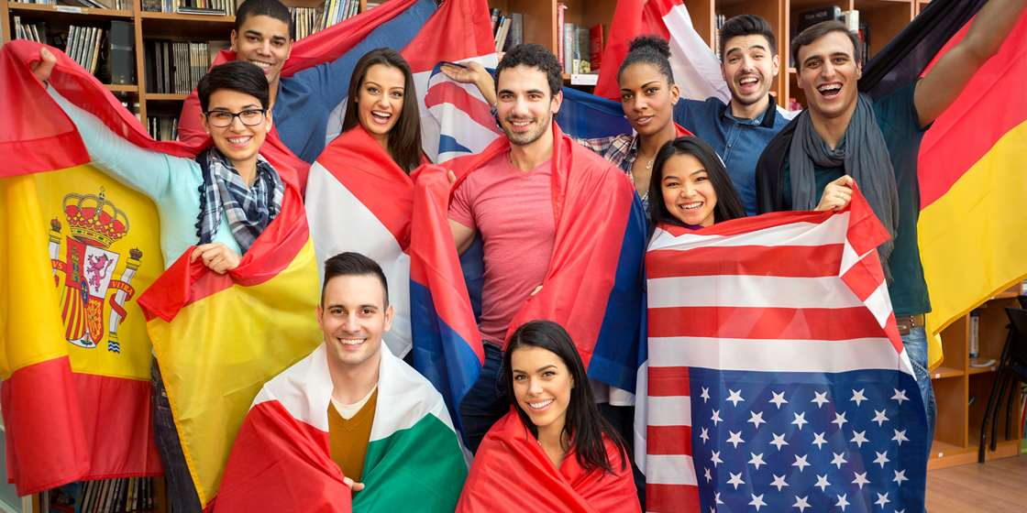
A student exchange program is a program in which students from a secondary school or university study abroad at one of their institution's partner institutions. A student exchange program may involve international travel, but does not necessarily require the student to study outside their home country.
Foreign exchange programs provide students with an opportunity to study in a different country and environment experiencing the history and culture of another country, as well as meeting new friends to enrich their personal development. International exchange programs are also effective to challenge students to develop a global perspective.
The term "exchange" means that a partner institution accepts a student, but does not necessarily mean that the students have to find a counterpart from the other institution with whom to exchange. Exchange students live with a host family or in a designated place such as a hostel, an apartment, or a student lodging. Costs for the program vary by the country and institution. Participants fund their participation via scholarships, loans, or self-funding.
Student exchanges became popular after World War II, and are intended to increase the participants' understanding and tolerance of other cultures, as well as improving their language skills and broadening their social horizons. Student exchanges also increased further after the end of the Cold War. An exchange student typically stays in the host country for a period of 6 to 10 months however, exchange students may opt to stay for one semester at a time . International students or those on study abroad programs may stay in the host country for several years. Some exchange programs also offer academic credit

- VOCABULARY
- Match the word/phrase in column A with its meaning or definition in column B.
No. | COLUMN A |  | COLUMN B
1. | abroad |  | - A room or rooms rented out to someone, usually in the same residence as the owner
2. | involve |  | - In or to a foreign country or countries.
3. | global |  | - The limit of a person's knowledge, experience, or interest
4. | lodging |  | - Relating to the whole world; worldwide.
5. | horizons |  | - Have or include (something) as a necessary or integral part or result

- (ii) Fill in the blanks with the correct words from the list above.aaa Make necessary
  - changes when needed.
    - They want to take full advantage of the Internet's connection to the ____ economy.
    - Why do they think they are so much better than everyone else when they go ____?
    - Both the New Town and the Old Town offer numerous ____in private houses and small family hotels.
    - she wanted to leave home and broaden her ____.
    - Sarah has been working at West Mid for the past 13 years and her job ____a variety of tasks.

- GRAMMAR FOCUS:The Use of, Other, the Otherand Another

Other
Other means ‘additional or extra’, or ‘alternative’, or ‘different types of’.

Other as a determiner
We can use other with singular uncountable nouns and with plural nouns:
- The embassy website has general information about visas. Other travel information can be obtained by calling the freephone number. (additional or extra information)
- Some music calms people; other music has the opposite effect. (different types of music)
- What other books by Charles Dickens have you read, apart from ‘Oliver Twist’?(additional or extra books)
- This one’s too big. Do you have it in other sizes? (alternative sizes)

If we use other before a singular countable noun, we must use another determiner before it:
- I don’t like the red one. I prefer the other colour.
- Not: I prefer other colour.
- Jeremy is at university; our other son is still at school.
- He got 100% in the final examination. No other student has ever achieved that.
- There’s one other thing we need to discuss before we finish.
Warning:
Other as a determiner does not have a plural form:
Mandy and Charlotte stayed behind. The other girls went home.
Not: The others girls …

- Determiners (the, my, some, this)

Other as a pronoun
We can use other as a pronoun. As a pronoun, other has a plural form, others:
We have to solve this problem, more than any other, today.
I’ll attach two photos to this email and I’ll send others tomorrow.

The other
- The other with a singular noun means the second of two things or people, or the opposite of a set of two:
- This computer here is new. The other computer is about five years old.
- Well, the gift shop is on the other side of the street, directly opposite. (the opposite side)
- Joel and Karen are here, but where are the other kids? (the remaining people in a group)

The other as a pronoun
We can use the other as a pronoun, especially to refer back to something which has been mentioned already in the sentence:
- He had his hat in one hand and a bunch of flowers in the other.
- She has two kittens, one is black and the other is all white.

Another
When we use the indefinite article an before other, we write it as one word: another. Another means ‘one more’ or ‘an additional or extra’, or ‘an alternative or different’.

Another as a determiner
We use another with singular nouns:
- Would you like another cup of coffee?
- You’ve met Linda, but I have another sister who you haven’t met, called Margaret.
- I don’t like this place. Is there another café around here we could go to? (alternative or different)

Another as a pronoun
We can use another as a pronoun:
The applications are examined by one committee, then passed on to another.

  - Choose the letter of the word or group of words that best completes the sentence.
- I have been to New Zealand, Australia and many ___ countries.  - another  - other  - others  - the others | - Where is ____ shoe? There is only this one in the shoe rack.  - another  - other  - others  - the other
- I've talked to Josh and Sarah, but I haven't talked to ____ students yet.  - another  - other  - others  - the others | - Ask me ___ question if you want. I know all the answers.  - another  - other  - others  - the others
- I think you should see ___ people.
  - another
  - other
  - others
  - the others

  - In these questions, each sentence has four underlined words or phrases. The four underlined parts of the sentence are marked (A), (B), (C) and (D). Identify the one underlined word or phrase that must be changed in order for the sentence to be correct. Then, on your answer sheet, find the number of the question and fill in the space that corresponds to the letter of the answer you have chosen.

1. He has two brothers. One is tall and handsome and other is short and unattractive.
(A) (B) (C) (D)

2. Some people voted 'yes', some people voted 'no', and another didn't vote.
(A) (B) (C) (D)

3. They have three color caps, one is blue and the others is green.
(A) (B) (C) (D)
4. We have to find out others people to help us constructing the bridge.
(A) (B) (C) (D)
5. They havenot met each others for long time.
(A) (B) (C) (D)

- WRITING:Sentence Construction
Now practice writing sentences usinganother, other(s) and the other(s)
    - Re-arrange these scrambled words into correct sentences.
  - coffee – make – of – I'll – another – pot.
............................................................................................................
  - want – Do – another – try – you – to –? – give – it
............................................................................................................
  - students – like –other– many, school – Tom – a – rides – bicycle – to.
................................................, ..........................................................
  - each – two – who – Tom – don't – know – girlfriends – about – has –other.
............................................................................................................
  - the – person –He's – not – kind –criticizes –of – who – others– always.
............................................................................................................

    - Continue these sentence chunks to make correct and meaningful sentences using another, other or the other.
  - I know I have failed, but ...................................................................
  - This t-shirt is too tight. Please ..........................................................
  - There are five applicants today, one is .............................................
  - Language enables us .........................................................................
  - Mount Merapi is higher than ............................................................
LESSON 7
MOBILE PAYMENT

- READING
Read the article carefully and then answer the following question
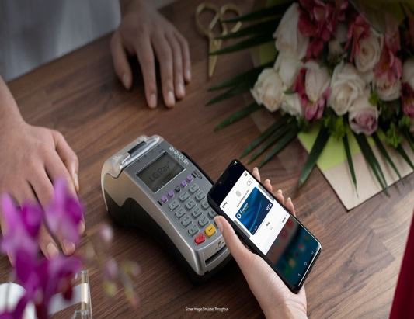
Mobile payment (also referred to as mobile money, mobile money transfer, and mobile wallet) generally refer to payment services operated under financial regulation and performed from or via a mobile device. Instead of paying with cash, cheque, or credit cards, a consumer can use a mobile to pay for a wide range of services and digital or hard goods. Although the concept of using non-coin-based currency systems has a long history, it is only in the 21st century that the technology to support such systems has become widely available. Mobile payment is being adopted all over the world in different ways. The first patent exclusively defined "Mobile Payment System" was filed in 2000.
In developing countries mobile payment solutions have been deployed as a means of extending financial services to the community known as the "unbanked" or "underbanked", which is estimated to be as much as 50% of the world's adult population, according to Financial Access' 2009 Report "Half the World is Unbanked". These payment networks are often used for micropayments. The use of mobile payments in developing countries has attracted public and private funding by organizations such as the Bill & Melinda Gates Foundation, United States Agency for International Development and Mercy Corps.
- COMPREHENSION
Answer these questions briefly.
    - Besides smoking, what are the threats to Americans today?
    - What does fast food contain?
    - Explain the meaning of these words/phrases
      - A beautiful corpse (par.1)
      - meat-based carcinogens (par.2)
      - to shave a few seconds off everything (par.3)
    - What is the effect of the dominance of the fast-food culture?
    - What does the statement “Not only is the food dangerous, but it promotes a lifestyle and culture that are also dangerous” mean? (par.4)

- VOCABULARY
- Match the word/phrase in column A with its meaning or definition in column B.
No. | COLUMN A |  | COLUMN B
1. | refer |  | - a person who purchases goods and services for personal use
2. | consumer |  | - able to be used or obtained; at someone's disposal
3. | currency |  | - make mention of, make reference to
4. | available |  | - bring into effective action.
5. | patent |  | - cause (someone) to have a liking for or interest in something.
6. | deployed |  | - roughly calculated; approximate
7. | estimated |  | - a government authority or licence conferring a right or title for a set period, especially the sole right to exclude others from making, using, or selling an invention.
8. | attracted |  | - a system of money in general use in a particular country.

- Fill in the blanks with the correct words from the list above.
- This option is only _____ to those able to pay an initial consultation fee.
- Everyone has one or two names and is _____to as the son or daughter of his or her father.
- It found that more than half of garages were delivering low standards of service to _____`.
- We are simply _____our resources to best effect.
- it is _____ that smoking causes 100,000 premature deaths every year
- You may need to be careful you don't lose money if there is a transfer between _____.
- I was _____to the idea of working for a ballet company.
- To him, the process of ________ seems the best possibility for mankind, no matter how harebrained, unreasonable or hilarious the scheme.

- GRAMMAR: If Clause
If-clauses are also known as conditional clauses or conditional sentences. This means that the event in the main clause (not counting the if) only takes place if the condition in the clause containing if is fulfilled.
There are 3 types:
If clauses type 1
It is possible and also very likely that the condition will be fulfilled.
Example:
- We will send you a message if we get to the city.
- If Shafa has some money, she will donate it.

If clauses type 2
It is possible but very unlikely, that the condition will be fulfilled.
Example:
- Bimo would invite Citra and Elma if he met them.
- If we won the game, we would be very happy.
If clauses type 3
It is impossible that the condition will be fulfilled because it refers to the past.
Example:
- If I had found her address, I would have sent her an invitation.
- If our team had won the match, they would have moved up in the league.

  - Choose the letter of the word or group of words that best completes the sentence.
- My dad ________ my bike if it is broken..  - repair`  - repairs  - repaired  - repairing | - If the temperature _________ below zero, it will freeze.  - fall  - falls  - fell  - is falling
- If they forgot the map, they ___ our way.  - lost`  - lose  - will lose  - would lose | - They _____ ill if they ________ that water.  - are - drink`  - will - drink  - will be – drink  - would - drink
  - Fill in the blanks with the correct forms of the verbs.
Type 1
- You _________ the train if you ________ earlier. (catch / leave)
- The reporter ________ photos, she ________ him for them. (take /ask)

Type 2
- ________you ________ the presentation if I _______ you a CD? (copy give)
- They ________ the TV if the guests ________ too early. (watch / not come)

Type 3
- ________ you ________ the cups on the table if I _______ them to you? (put / pass)
- He _______ you the photos if he ______ them from the shop. (show /fetch)

- WRITING:Sentence Construction
Now practice constructing sentences usingif-clauses
        - Continue these sentence fragments to make corrrect and meaningful sentences.
    - If I have a lot money, ..................................................................................................
    - If you don't hurry, .......................................................................................................
    - If you are lost, .............................................................................................................
    - If it rained, ...................................................................................................................
    - If you went to bed earlier, ...........................................................................................
    - If your smartphone was damaged, ..............................................................................
    - If I spoke some foreign languages, .............................................................................
    - If I were the president of the Republic of Indonesia, ..................................................
    - If I had accepted that promotion, .................................................................................
    - If I had studied harder, .................................................................................................

