Many people in big cities start their day early in the morning. Some of them have to rush to the office early because they do not want to miss the public transport. What about you? Do you get up early in the morning? What time do you start your day? What time do you usually get up in the morning? Please share your daily activities with the class.

- READING
Read this text and look at the pictures, and then answer the questions.
On Mondays, I wake up, then I go to the bathroom, and I take a shower. After that I go to the kitchen for breakfast.

I eat ‘Pastelitos’ and I drink Coca-cola, when I finish my breakfast I go to URBE.

I start my class from 8 to 12.20. I arrive at home at 2 pm, and then I have my lunch at 3 pm.

After that I take a rest and then I play soccer with my friends. When I return home, I do my homework.

In the night, I have my dinner, and then I take a shower. Finally, I go to bed at midnight.
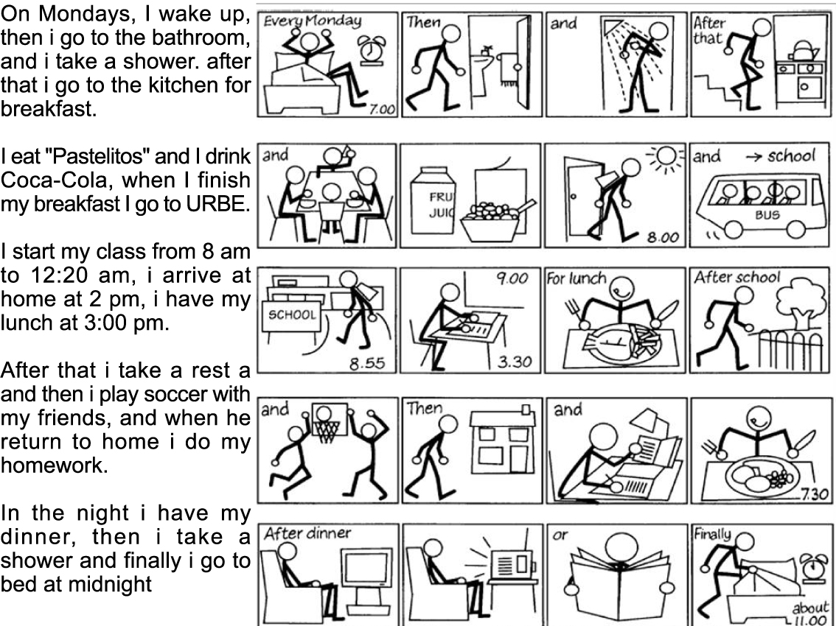
Answer these Questions correctly!
Note:
a.m.: from midnight till noon
p.m.: from noon till midnight

- What does the man do after taking a shower?
- What does he eat for his breakfast?
- What time does he start his class?
- How does he go to school?
- Whom does he play soccer with?
- What does he do before going to bed?
- Does he sleep at midnight?

- GRAMMAR FOCUS: WH-Question Words
Study the use of question words below:
- WHAT is used for asking about things/ objects.
Examples:
What is your name?
What do you do after having dinner?
What color do you like most?
- WHEN is used for asking about time.
Examples:
When is your birthday?
When did they go to Bali?
When will you finish your study?
- WHERE is used for asking about place/location.
Examples:
Where is he from?
Where are young going to go?
Where have you been?
- HOW is used for asking about manner/ way to do something.
Examples:
How do you go to campus?
How will you do your home assignment?
How did they drive the cars?
- WHO is asking for asking about people (subject).
Examples:
Who invented computer?
Who will accompany her to the doctor?
Who is wearing the red polo-shirt?
- WHOM is asking for asking about people (object).
Examples:
Whom do you live with?
Whom did she talk to?
Whom are they going to share their room with?

- GRAMMAR PRACTICE
I. Supply the sentences with what, where, when, who, or how.
- _____ was Jovita born? -I guess she was born in Liwa, West Lampung.
- _____ do you spend your leisure time? -listening to music.
- _____ do you need to make the cake. -a kilo of sugar, some butter, a dozen eggs, and flour.
- _____ teaches you algoritm this semester? -Professor Benno does.
- _____ is Siger tower located? -in Kalianda, South Lampung.
- _____ does Ivan ride his bike? -very fast.
- _____ kinds of music do you like? -R n B and Pop.
- _____ did you meet her for the first time? -last year.

II. Answer the questions based on the picture. Look at the example.
- Where are they?
They are in the campus

- What do they do in the campus?
They study in the Campus
- Do they have a picnic?
No, They don’t. They study in the campus.

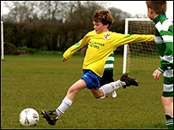

- Where is he?
…………………………………..
- What does he do?
……………………………………
- Does he play basketball?
No.……………………………………

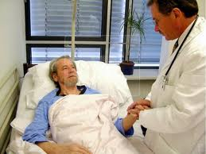
- Where is he?
………………………………….
- What does he do?
…………………………………..
- Does he check the patient’s health?
Yes……………………………….


- Where is she?
…………………………………..
- What does she do?
……………………………………
- Does she have a meeting?
No ………………………………

- READING
Read the text carefull and then answer the questions.

My Daily Routine
It seems my life is always very full of activities and obligations, so I never have much time for myself. During the week it's the worst. I usually have to get up at half past six even though I would really prefer to sleep much later. After I get up, I perform my morning routine of washing my face, brushing my teeth, and then deciding what to wear. After I get dressed, I brush my hair. I usually don’t have time for breakfast in the morning because I have to catch a bus at seven o'clock for my commute to campus. The bus is usually completely packed and it really makes me envy my friends who don't have to ride the bus to campus. Classes at school start at a quarter to eight except on Tuesdays when they start at seven. Each class has its own timetable, so my schedule varies by class. Classes are forty-five minutes long with ten minutes breaks, except for one "long" break between the third and the fourth classes, which is twenty minutes long. My classes take place either in our classroom or in various labs or a gym. After our classes the students usually go for lunch to the canteen. Some students in their third and forth semester have afternoon classes, seminars, optional after-campus activities or driving lessons. After studying in my campus I sometimes go shopping or just walk around the town for a while. When I get home, I like to relax for some time; I listen to the radio, watch television, and maybe get a little snack. Then I start my homework or help with some housework. Before I know it, the afternoon is gone and it is evening. In my family, we usually eat dinner at about seven o'clock. At dinner we discuss what happened during the day and catch up with each others' lives. After I help to clean up the dinner dishes, I either take a shower or have a bath myself. Then, I have some time to watch the TV news. Sometimes I watch an interesting film or music program on TV or a video. Sometimes I like to go downtown to see a movie or to go to a concert with my friends. About every other day I have a date with my boyfriend. Sometimes he comes to watch TV at my home or we might go out for a walk. I usually manage to go to bed around eleven p.m.
That’s all about my daily routine during the week. On the weekend it is a different story, I like to sleep late and do whatever I wish with my free time. I am still expected to help my parents out around the house but I still have most of the time for myself and my interests. I can go for a trip with my friends, I can visit my relatives or I can devote more time to my hobbies. I think everyone will agree that weekends are much better than weekdays.

Questions:
- What is the writer’s morning routine?
- What time does the writer’s class start on Tuesday?
- How long does each class last?
- According to the text, what places are used for learning?
- Is the writer male or female? How do you know?

- WRITING
Write a paragraph telling about your weekend routine.

…………………………………………………………………………………………………
…………………………………………………………………………………………………
………………………………………………………………………………………..………..
…………………………………………………………………………………………………
…………………………………………………………………………………………………
………………………………………………………………………………………..………..
…………………………………………………………………………………………………
…………………………………………………………………………………………………
………………………………………………………………………………………..………..
…………………………………………………………………………………………………
…………………………………………………………………………………………………
………………………………………………………………………………………..………..
…………………………………………………………………………………………………
………………………………………………………………………………………..………..
…………………………………………………………………………………………………
………………………………………………………………………………………..………..

