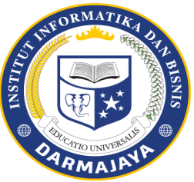
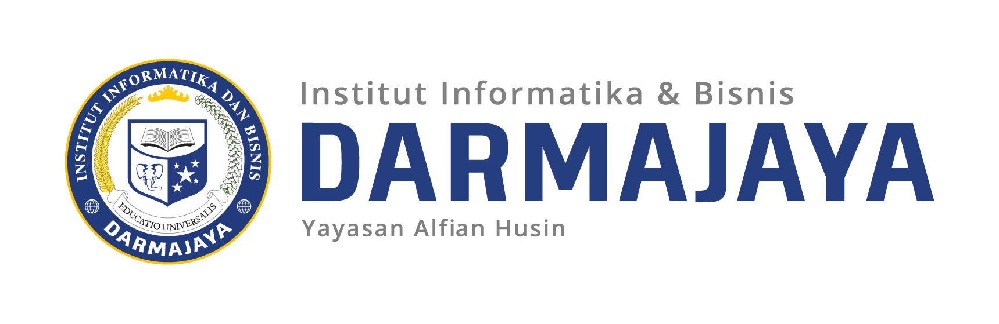

SOAL UJIAN AKHIR SEMESTER GENAP TA. 2023/2024

KODE MK : FIK21203 DOSEN : Peer Group
MATA KULIAH : Bahasa Inggris WAKTU : 90 Menit
JURUSAN : S1 Information System /Science Data KELAS : 6SI1/2, 2SD1
SIFAT : OPEN/CLOSE BOOK ^{(*)} HARI : -
KET : TEORI/PRAKTIKUM ^{(*)} TANGGAL : -

- Read the text below and then answer the following questions
Social media specialist skills in the workplace
In today's digitally driven world, social media has become the new frontier for brand building and
customer engagement. But navigating this ever-evolving landscape requires a unique skill set: the magic touch of a social media specialist. These digital wizards possess a potent combination of strategic thinking and on-the-ground execution, transforming online spaces into thriving communities for brands.
At the core of a social media specialist's expertise lies strategic thinking. They are the architects, crafting data-driven plans that align social media efforts with the company's overarching marketing goals. This requires a deep understanding of the target audience, a keen eye on competitor activity, and the ability to identify the most effective platforms to reach those demographics. They are the cartographers, meticulously charting content calendars that cater to each platform's specific algorithms and trends, ensuring content resonates with the right audience at the right time. However, strategy without execution is like a map without a journey. This is where the execution skills come into play.
Social media specialists are the Michelangelos of the digital world, wielding creativity to craft compelling content. They sculpt engaging text, curate eye-catching visuals, and potentially even film captivating videos, all tailored to resonate with their target audience and achieve brand objectives. But their impact transcends content creation. They are also community builders, fostering a thriving online space by actively engaging with followers. They respond promptly and professionally to comments and messages, addressing concerns and cultivating a sense of loyalty. This extends to customer service, adeptly handling inquiries, and maintaining a positive brand image.
Furthermore, social media specialists are masters of technology. They wield various social media management tools like scheduling platforms and analytics dashboards. These tools streamline workflows, manage content calendars, and provide valuable insights into campaign performance. Effective collaboration is also paramount. Social media specialists act as the bridge between the marketing department, the design team, and even sales, ensuring all aspects of social media efforts are aligned with the broader company goals.
While some additional skills can enhance a social media specialist's toolkit, the core remains the same. A keen eye for design allows for crafting visually stunning content, while strong copywriting skills ensure clear and engaging messaging. However, the most valuable asset a social media specialist possesses is their adaptability. The social media landscape is in constant flux, with new trends and platforms emerging continuously. The ability to learn new tools, stay updated on the latest innovations, and continuously refine their approach is essential for sustained success.
In conclusion, social media specialists are more than just content creators; they are strategic thinkers, community builders, and tech-savvy collaborators. By wielding the potent combination of strategy and execution, they transform online spaces into thriving brand communities, driving awareness, engagement, and ultimately, measurable results in the dynamic world of social media. Their skills are the modern Midas touch, turning digital interactions into brand gold.

- According to paragraph 2, What are the key components of strategic thinking for a social media specialist?
- How does the metaphor of "a map without a journey" explain the importance of execution skills in social media strategy (paragraph 2)?
- How does a social media specialist's role go beyond content creation, according to paragraph 3?
- What specific skills does adaptability encompass for a social media specialist, based on paragraph 5?
- How does the passage describe the role of a social media specialist in other departments within a company?

- Match the word in column A with the meaning or definition in column B
No | Column A | Column B
1 | Job Opportunities | - The abilities and competencies you develop and improve over time that enable you to perform effectively in a work environment
2 | Software Development | b.The process of planning, organizing, executing, monitoring, and controlling activities to achieve specific goals within a defined timeframe, budget, and scope.
3 | Professional Skills | c.Openings for employment
4 | Project Management | d.The bridge between human creativity and the world of digital applications
5 | Data Access | e. The abilities you use to identify, analyze, and overcome challenges
6 | Problem-solving skills | f.The ability of authorized users to retrieve, modify, copy, or move data within IT systems
7 | Social Media | g.The software that allows you to efficiently store, retrieve, manage, and manipulate large collections of data electronically
8 | Database System | h.Interactive digital platforms that connect people and communities
9 | Security Awareness | i.Letter of Application
10 | Cover Letter | j.The knowledge and understanding that individuals within an organization possess regarding the protection of its assets, primarily focusing on information security. It encompasses an individual's:

- Making the dialoges between applicant and manager of comapany about the job interview (minimum is 250 words)

