Fifth Meeting
English I
Ms. Nia Sari Nastiti, M.Pd

LESSON 3

DIGITALMARKETING

- READING
Read the reading passage carefully and then answer the following question.
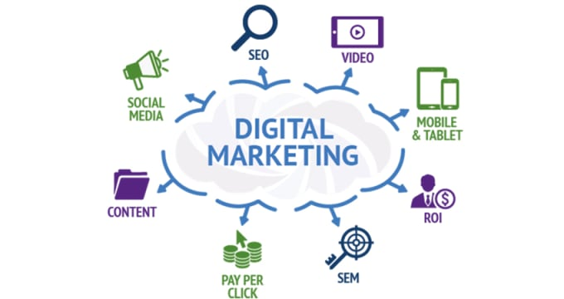
Digital marketing is the marketing of products or services using digital technologies, mainly on the Internet, but also including mobile phones, display advertising, and any other digital medium. Digital marketing channels are systems based on the internet that can create, accelerate, and transmit product value from producer to the terminal consumer by digital networks.
Digital marketing's development since the 1990s and 2000s has changed the way brands and businesses use technology for marketing. As digital platforms are increasingly incorporated into marketing plans and everyday life, and as people use digital devices instead of visiting physical shops, digital marketing campaigns are becoming more prevalent and efficient.
Digital marketing methods such as search engine optimization (SEO), search engine marketing (SEM), content marketing, influencer marketing, content automation, campaign marketing, data-driven marketing, e-commerce marketing, social media marketing, social media optimization, e-mail direct marketing, Display advertising, e–books, and optical disks and games are becoming more common in our advancing technology. In fact, digital marketing now extends to non-Internet channels that provide digital media, such as mobile phones (SMS and MMS), callback, and on-hold mobile ring tones. In essence, this extension to non-Internet channels helps to differentiate digital marketing from online marketing, another catch-all term for the marketing methods mentioned above, which strictly occur online.

