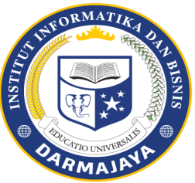
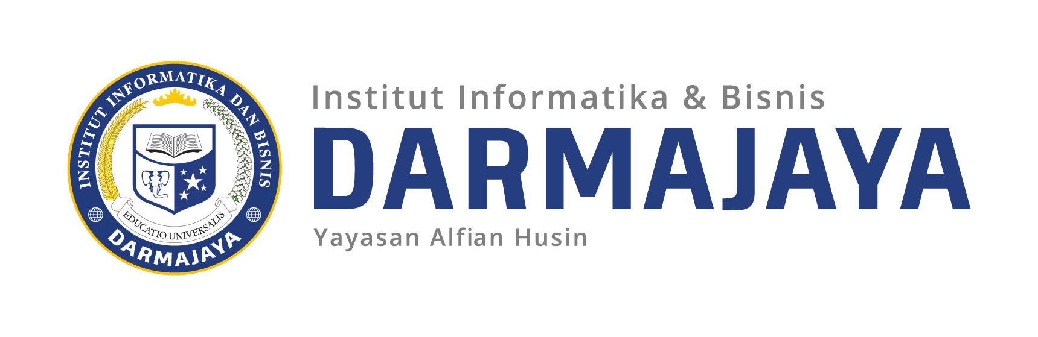

SOAL UJIAN TENGAH SEMESTER GENAP TA. 2019/2020

MATA KULIAH : Digital Marketing DOSEN : Dr. Anggalia Wibasuri, M.M.
KODE MK : MMA3118319 WAKTU : 75 Menit
JURUSAN : MM KELAS : 3MM-01
SIFAT : Open Book ^{(*)} HARI /TANGGAL :
KET : TEORI ^{(*)}

Along with the widespread use of the internet in various aspects of today's life, Digital Marketing is becoming increasingly popular and important. In general, Digital Marketing is any form of marketing activities for products or services using digital technology, especially the Internet, and including cellular phones.
Digital Marketing, which has evolved since the 1990s, has changed the strategy of companies and brands using technology for marketing. As more and more companies are incorporating digital marketing as one of their marketing strategies, and more and more people are shopping online, digital marketing campaigns are becoming a necessity and increasingly efficient.
In this test answer the following questions carefully and seriously.
1. How do you explain digital marketing?
2. What part of digital marketing really needs to be mastered?
3. Can you name any online marketing tools that are useful in improving digital marketing performance?
4. In your opinion, what are the digital marketing trends that will soon dominate the market?

