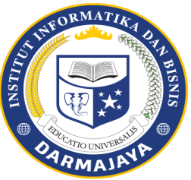
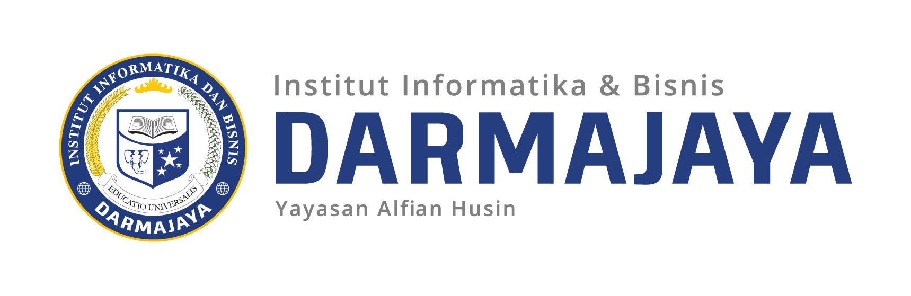
FINAL EXAMS SEMESTER 2019/2020

ID : IBI19207 LECTURE : Rina Milyati Y.,SE.,M.M
SUBJECT : Pengembangan Bisnis DURATION : 75 Minutes
DEPARTMENT : S1 - Manajemen CLASS : 4MA-P1i
TYPE : OPEN/CLOSE BOOK ^{(*)} DAY : Wednesday
ADD : TEORI/PRAKTIKUM ^{(*)} DATE : july 29,2020

Direction :
- Pray according to their respective believ.
- Answer the question that you think are easy first
- It is not allowed to carry out discussions through Hp
- Answer sent to lms.darmajaya

Question:
- Make a complete evaluation of the business development product progress report of your business on”
- inspiration to start a business
- why you made the product
- what is the innovation in your product
- how is the canvas business model

