- READING
Read the reading passage carefully and then answer the following question.
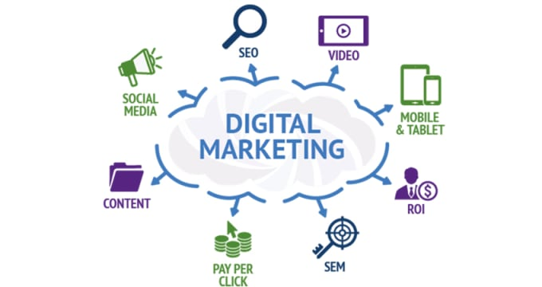
Digital marketing is the marketing of products or services using digital technologies, mainly on the Internet, but also including mobile phones, display advertising, and any other digital medium. Digital marketing channels are systems based on the internet that can create, accelerate, and transmit product value from producer to the terminal consumer by digital networks.
Digital marketing's development since the 1990s and 2000s has changed the way brands and businesses use technology for marketing. As digital platforms are increasingly incorporated into marketing plans and everyday life, and as people use digital devices instead of visiting physical shops, digital marketing campaigns are becoming more prevalent and efficient.
Digital marketing methods such as search engine optimization (SEO), search engine marketing (SEM), content marketing, influencer marketing, content automation, campaign marketing, data-driven marketing, e-commerce marketing, social media marketing, social media optimization, e-mail direct marketing, Display advertising, e–books, and optical disks and games are becoming more common in our advancing technology. In fact, digital marketing now extends to non-Internet channels that provide digital media, such as mobile phones (SMS and MMS), callback, and on-hold mobile ring tones. In essence, this extension to non-Internet channels helps to differentiate digital marketing from online marketing, another catch-all term for the marketing methods mentioned above, which strictly occur online.

- COMPREHENSION
Answer these questions briefly.
    - What is the best title of the article?
    - What do digital marketing channels function?
    - What do you know about digital marketing methods?
    - How do you interpret this sentence “people use digital devices instead of visiting physical shops”? (line 8)
    - How digital marketing and online marketing differ?

- VOCABULARY
      - Match the word/phrase in column A with its meaning or definition in column B.
No. | COLUMN A |  | COLUMN B
1. | digital |  | - line, label, marque
2. | value |  | - widespread, prevailing, frequent,
3. | consumer |  | - typically represented by values of a physical quantity such as voltage or magnetic polarization
4. | accelerate |  | - by itself with little or no direct human control.
5. | brands |  | - worth, usefulness, use,
6. | platforms |  | - make available for use; supply.
7. | prevalent |  | - purchaser, buyer, customer,
8. | provide |  | - expand, enlarge, increase,
9. | extends |  | - speed up, hurry up, get faster,
10. | differentiate |  | - make (someone or something) appear different or distinct

      - Fill in the blanks with the correct words from the list above.aaa Make necessary changes when needed.
- We plan to support more hardware ____ and operating systems.
- The receiving modem translates the analog signals back to ____ form.
- The group is active in repairing schools and ____ `educational supplies.
- Professional psychology has always emphasized the ____ `of respecting privacy.
- Pilots have spoken of the dangerous winds ____ in the area where the friends were last heard from.
- The job of businessmen is to stay on guard as far as ____ s' demands are concerned.’
- It is for the same reason the council has asked for the boundary to be ____ in the Chalumna area.
- Biotechnology will continue to advance and its rate of advance will ____.
- Three characteristics or properties ____ laser light from ordinary light.
- There are ____, products and categories and each has a slightly different meaning.

