CAUSE AND EFFECT PARAGRAPH
In this unit, you are going to study how to write a cause and effect paragraph.
- Definition
Cause and Effect paragraph is the paragraph made by two (2) ways; by describing the effects or by describing causes of the chosen topics

- Causes is to write the reason from which the topic is explained
- Effect is to write the result to which the topic is explained
*As the writer, you could write a cause and effect paragraph through one (1) of these ways – describing causes or describing effect (choose one of them).

- Structure of Cause and Effect Paragraph:
- At this explanation, the writer choose HAPPINESS as the topic/title
- The writer describes causes of HAPPINESS
- The Structure of the Paragraph can be:

HAPPINESS
INTRODUCTION | PARAGRAPH 1 | General Statement of Happiness
BODY OF PARAGRAPH | PARAGRAPH 2 | Cause 1: Preventing Social Comparison
BODY OF PARAGRAPH | PARAGRAPH 3 | Cause 2: To be True for self-personality
CONCLUSION | PARAGRAPH 4 | Rewrite the points briefly
**The “HAPPINESS” Paragraph can be seen on the page 2

- Language Feature of Cause & Effect Paragraph
- Use “Present Tense”
- Use Transitive Conjunction “However, Furthermore, Besides, Moreover, Therefore,”
- Use Correlative conjunction “Because, Although, Whereas”

Example:
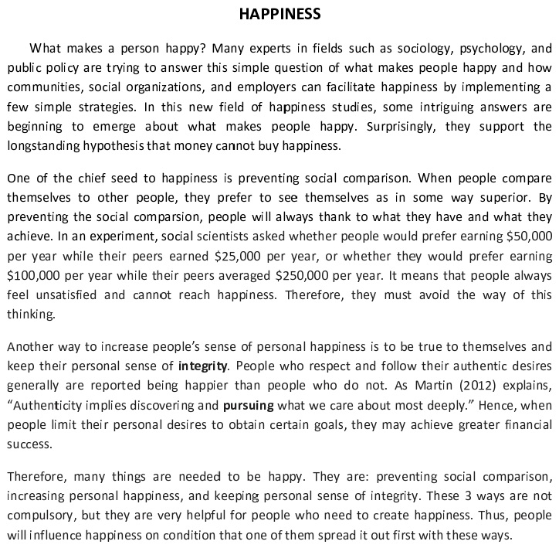

Introduction

Body of Paragraph

Conclusion

Exercise
1) Choose one (1) of the topics below.
a) Education
b) Technology
c) Environment
d) Economy

2) Write Cause and Effect Paragraph based on the topic you have chosen above

……………..

…………………....................................................................................................................................................................................................................................................................................................................................................................................................................................................................................................................................................................................................................................................................................................................................................................................................................................................................................................................................................................................................................................................................................................................................................................................................................................................................................................................................................................................................................................................................................................................................................................................................................................................................................................................................................................................................................................................................................................................................................................................................................................................................................................................................................................................................................................................................................................................................................................................................................................................................................................................
................................................................................................................................................
................................................................................................................................................
................................................................................................................................................
................................................................................................................................................

