Nama : ELING SUTAQWA
NPM : 2311059003P
Makuliah : Teknik Visualisasi
Kelas : 7SIS1
Jurusan : Sistem Informasi

Branch  Code | Customer  Code | Order  Date | Sales | Kelurahan | Kecamatan | City
703 | 11139373259 | 17/02/2007 | 289,029,597 | BAROS | ARJASARI | SOREANG
702 | 74466331208 | 12/11/2007 | 275,202,435 | PINGGIR SARI | ARJASARI | SOREANG
715 | 45253996635 | 01/04/2019 | 912,953,406 | BOJONG MALAKA | BALE ENDAH | BANDUNG
710 | 23127033896 | 21/02/2016 | 270,889,265 | MALAKA SARI | BALE ENDAH | BANDUNG
704 | 22146150823 | 05/18/2017 | 430,538,720 | BANJARAN | BANJARAN | SOREANG
708 | 53486854337 | 11/02/2016 | 291,488,646 | BOJONGSARI | BOJONG SOANG | SOREANG
717 | 87642270215 | 14/05/2016 | 132,601,927 | BUAH BATU | BOJONG SOANG | SOREANG
701 | 54306625421 | 22/05/2016 | 172,919,115 | PANUNJANG | CANGKUANG | BANDUNG
710 | 34291111133 | 23/06/2016 | 154,414,964 | BANDASARI | CANGKUANG | BANDUNG
707 | 32106976480 | 17/09/2016 | 803,561,531 | CIKUYA | CICALENGKA | BANDUNG
701 | 11281367356 | 22/10/2017 | 497,523,264 | DAMPIT | CICALENGKA | BANDUNG
716 | 23223739154 | 12/08/2016 | 983,128,215 | CIHANYIR | CIKANCUNG | BANDUNG
709 | 67711173122 | 14/09/2016 | 740,305,954 | CIKANCUNG | CIKANCUNG | BANDUNG
704 | 33410322738 | 12/09/2019 | 550,072,407 | CIPANJALU | CILENGKRANG | SOREANG
708 | 34585099898 | 19/06/2016 | 152,721,465 | GIRIMEKAR | CILENGKRANG | SOREANG
704 | 93289322827 | 28/10/2016 | 396,063,555 | JATI ENDAH | CILENGKRANG | SOREANG
703 | 56775937295 | 12/03/2017 | 972,335,422 | CIBIRU WETAN | CILENYUI | CIMAHI
709 | 66537881344 | 19/03/2018 | 275,990,222 | CIBIRU HILIR | CILENYUI | CIMAHI
703 | 33281998475 | 25/10/2015 | 251,044,392 | WARJABAKTI | CILEUYUI | CIMAHI

- Bar Chart
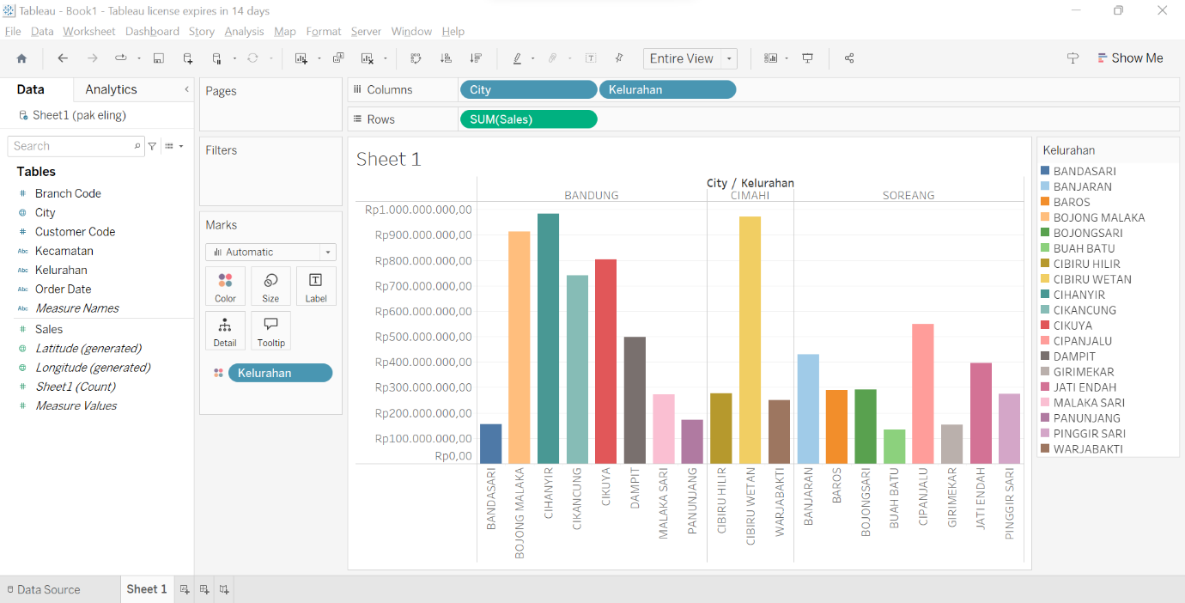

- Line Chart
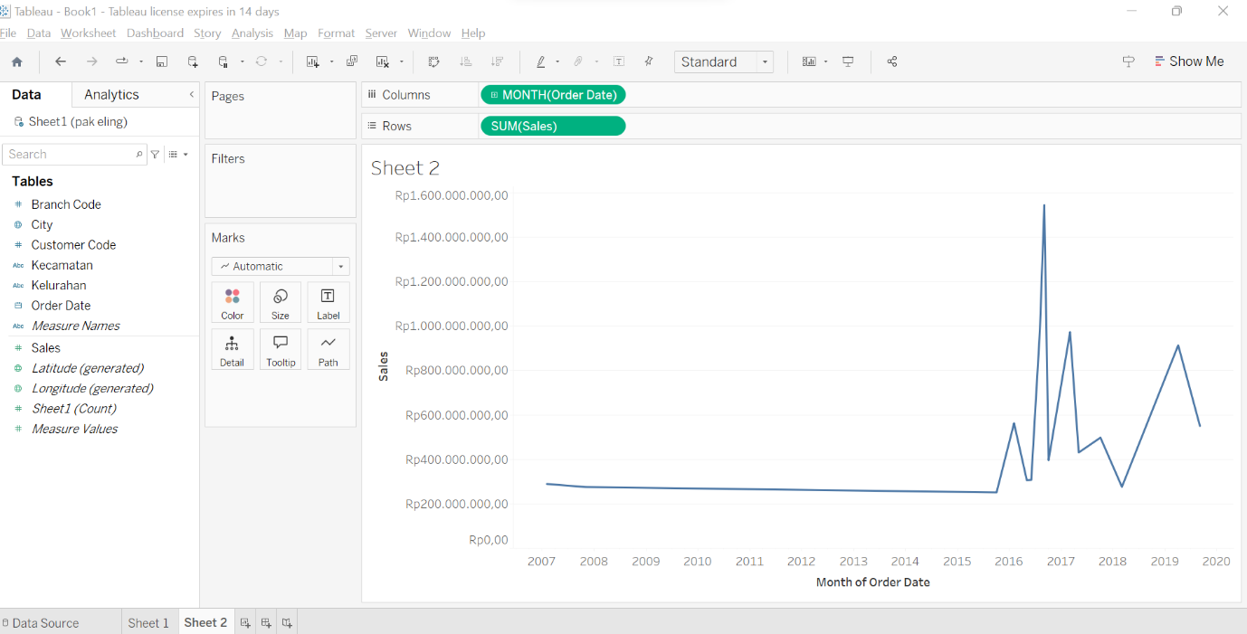

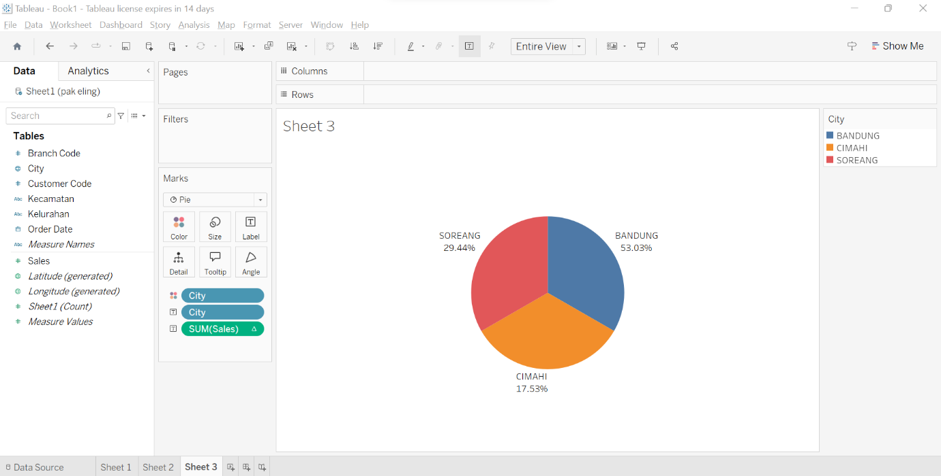
- Pie Chart

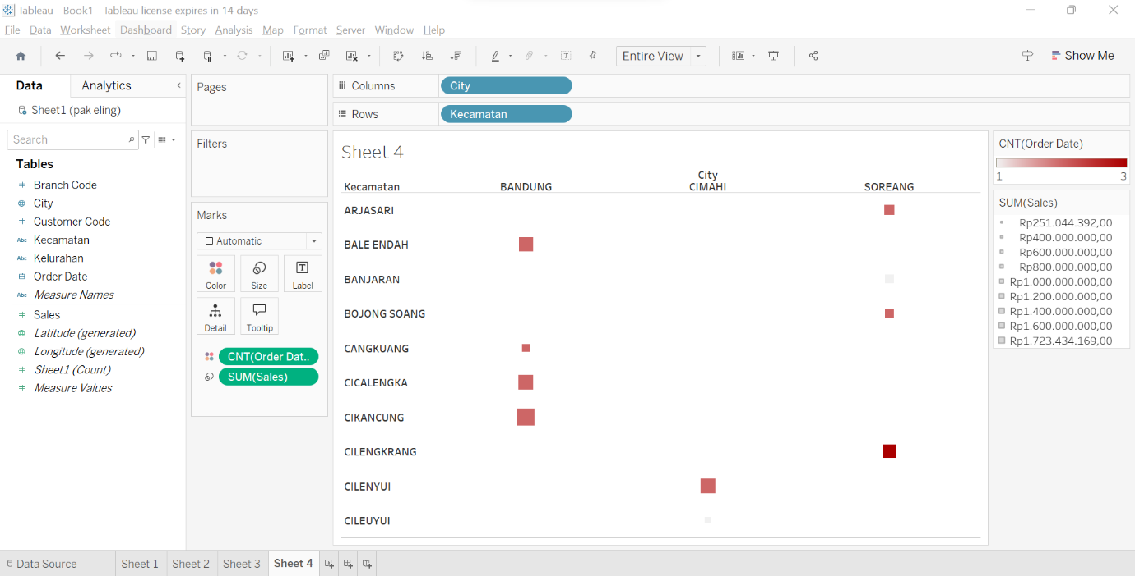
4. Heatmap

