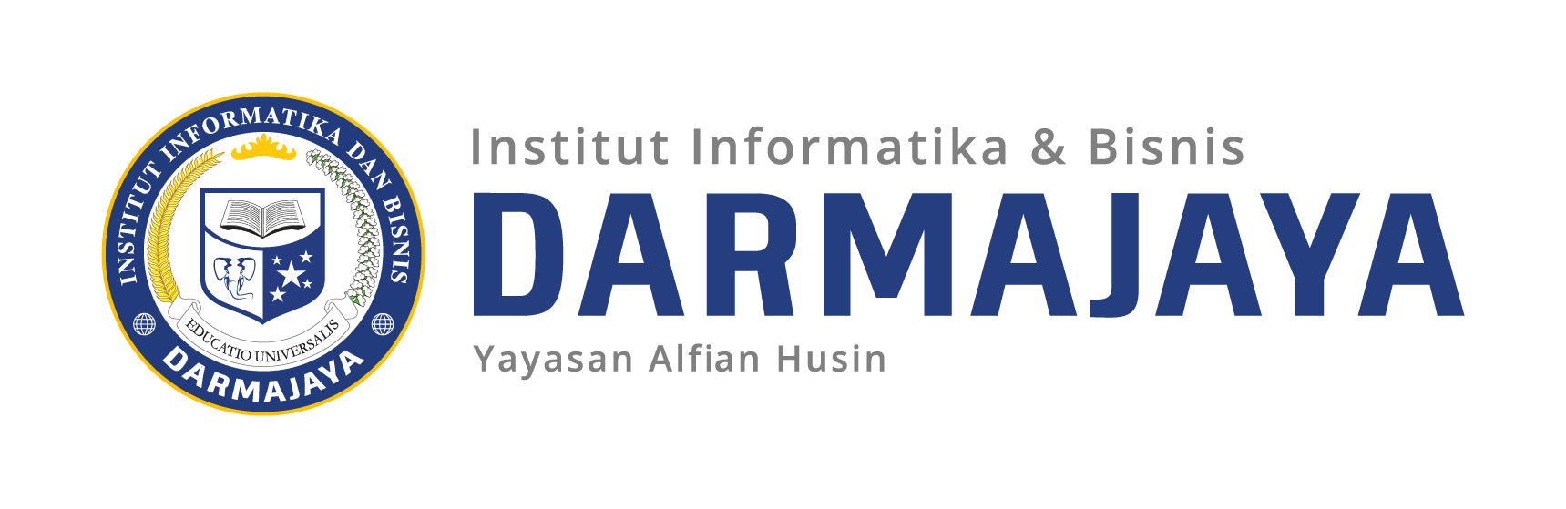
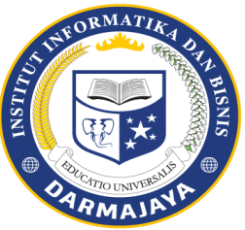

SOAL UJIAN TENGAH SEMESTER GANJIL TA. 2025/2026

KODE MK : DHP 23207 DOSEN : Gita Amelia, M.Pd
MATA KULIAH : English Profesi II WAKTU :
JURUSAN : Pariwisata KELAS : 2PA1
SIFAT : OpenBook/Close Book* HARI :
KET : TANGGAL :

Keterangan :
- Berdo’alah sebelum mengerjakan soal
- Tuliskan Nama, NPM dan Kelas pada lembar jawaban anda
- Jawablah terlebih dahulu soal yang dianggap lebih mudah
- Tidak diperkenankan mencontek, jika kedapatan mencontek maka peserta ujian akan di berikan nilai 0

I. Reading Comprehension
Read the following text carefully, then answer the questions!
Providing Excellent Service to Guests
In the tourism industry, providing excellent service to guests is very important. The first impression often begins with a polite greeting. When guests arrive, staff should welcome them warmly and make them feel comfortable.
Handling guests properly also includes listening carefully to their needs. Sometimes guests may ask for permission to use certain facilities or request special services. Staff should respond politely and clearly, ensuring that guests understand the rules.
Problems and complaints are common in hospitality. When a guest complains, staff should remain calm, apologize sincerely, and try to offer a solution. This shows professionalism and helps maintain a good relationship with the guest.
In addition, giving compliments can make guests feel appreciated. For example, staff can compliment guests politely on their choices or preferences. If staff do not understand a guest’s request, they should ask for repetition in a polite way.
In conclusion, good communication skills such as greeting, asking permission, handling complaints, and giving compliments are essential in tourism services.

Answer the following questions:
- Why is greeting important in the tourism industry?
- How should staff respond when guests ask for permission?
- What should staff do when handling complaints?
- Why is giving compliments useful in guest service?
- What should staff do if they do not understand a guest’s request?

II. True or False (T / F)
Choose T (True) or F (False)!
No | Sentence | T | F
1 | Greeting guests politely creates a good first impression. | ☐ | ☐
2 | Staff should ignore guest requests if they are busy. | ☐ | ☐
3 | Asking permission politely shows respect to guests. | ☐ | ☐
4 | Complaints should be handled with anger. | ☐ | ☐
5 | Listening carefully helps staff understand guest needs. | ☐ | ☐

III. True or False (Conditional Sentences)
Choose T (True) or F (False)!
No | Statement | T / F
1 | If you greet guests politely, they will feel welcomed. | ( )
2 | If staff ignore complaints, guests will feel satisfied. | ( )
3 | If you ask permission politely, guests will respect you. | ( )
4 | If you listen carefully, you will understand guest needs better. | ( )
5 | If a guest complains, you should respond rudely. | ( )

IV. Arrange the Sentences
Arrange the words into correct sentences!
- welcome / hotel / our / to / welcome / you
- help / may / you / I / today
- permission / ask / I / may / your
- complaint / handled / politely / the / staff / the
- guest / compliment / the / service / the
- repeat / could / please / you / that
- problem / solved / the / quickly / staff / the
- greeted / warmly / the / guest / was
- request / clearly / explained / the / guest / the
- service / excellent / provided / they

>>> Good Luck <<<

SOAL SUSULAN UJIAN TENGAH SEMESTER GANJIL TA. 2025/2026

KODE MK : DHP 23207 DOSEN : Gita Amelia, M.Pd
MATA KULIAH : English Profesi II WAKTU :
JURUSAN : Pariwisata KELAS : 2PA1
SIFAT : OpenBook/Close Book* HARI :
KET : Teori TANGGAL :

Keterangan :
- Berdo’alah sebelum mengerjakan soal
- Tuliskan Nama, NPM dan Kelas pada lembar jawaban anda
- Jawablah terlebih dahulu soal yang dianggap lebih mudah
- Tidak diperkenankan mencontek, jika kedapatan mencontek maka peserta ujian akan di berikan nilai 0

Handling Guests Professionally
Working in the tourism industry requires good communication skills. One of the most important skills is greeting guests in a friendly and professional way. A simple smile and polite words can make guests feel comfortable.
When dealing with guests, staff must be ready to help at any time. Guests often ask for permission, such as using hotel facilities or requesting special services. Staff should respond clearly and politely to ensure good understanding.
Sometimes problems occur, and guests may complain. In this situation, staff should listen carefully, apologize, and offer the best possible solution. Handling complaints properly can turn a negative experience into a positive one.
In addition, giving compliments is a good way to build a friendly relationship with guests. If staff do not hear or understand something, they should politely ask the guest to repeat the information.
Overall, professionalism, politeness, and clear communication are key to excellent service.

Answer the questions:
- What is the role of greeting in guest service?
- How should staff respond to guest requests or permissions?
- What is the correct way to handle complaints?
- How can compliments help staff in dealing with guests?
- What should staff do if they do not understand a guest?

II. True or False (T / F)
Choose the correct answer!
No | Sentence | T | F
1 | Friendly greetings can make guests feel comfortable. | ☐ | ☐
2 | Staff should refuse all guest requests. | ☐ | ☐
3 | Apologizing is important when handling complaints. | ☐ | ☐
4 | Compliments are not useful in tourism service. | ☐ | ☐
5 | Asking politely shows professionalism. | ☐ | ☐

III. Arrange the Sentences
Arrange the words into correct sentences!
- you / assist / may / I / today
- very / your / nice / is / choice
- repeat / please / could / that / you
- sorry / the / inconvenience / for / we / are
- permission / ask / I / may / to / enter
- guest / the / warmly / greeted / staff / the
- problem / quickly / the / solved / they
- service / excellent / provided / hotel / the
- complaint / carefully / listened / the / staff
- help / need / you / do / any

IV. Short Dialogue Completion
Complete the dialogue!
Receptionist: Good afternoon, welcome to our hotel.
Guest: Good afternoon. __________ (1)
Receptionist: Certainly. May I have your name, please?
Guest: __________ (2)
Receptionist: Thank you. Here is your key.
Guest: __________ (3)
Receptionist: You’re welcome. Enjoy your stay.

>>> Good Luck <<

